**Q1: Program to print name with character.**

**Code:**

dosseg

.model small

.stack 100h

.data

.code

main proc

mov dl,'L'

mov ah,2

int 21h

mov dl,'U'

mov ah,2

int 21h

mov dl,'T'

mov ah,2

int 21h

mov ah,4ch

int 21h

main endp

end main

**Output:**

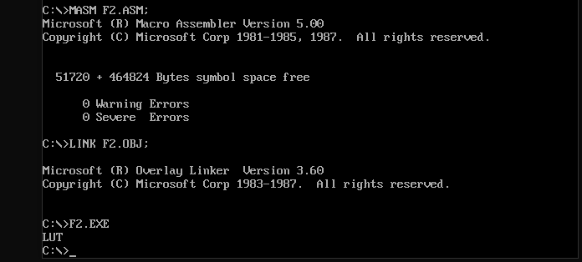

**Q2: Program to take input character and print on screen.**

**Code:**

dosseg

.model small

.stack 100h

.data

.code

main proc

mov ah,1

int 21h

mov dl, al

mov ah,2

int 21h

mov ah,4ch

int 21h

main endp

end main

**Output:**

